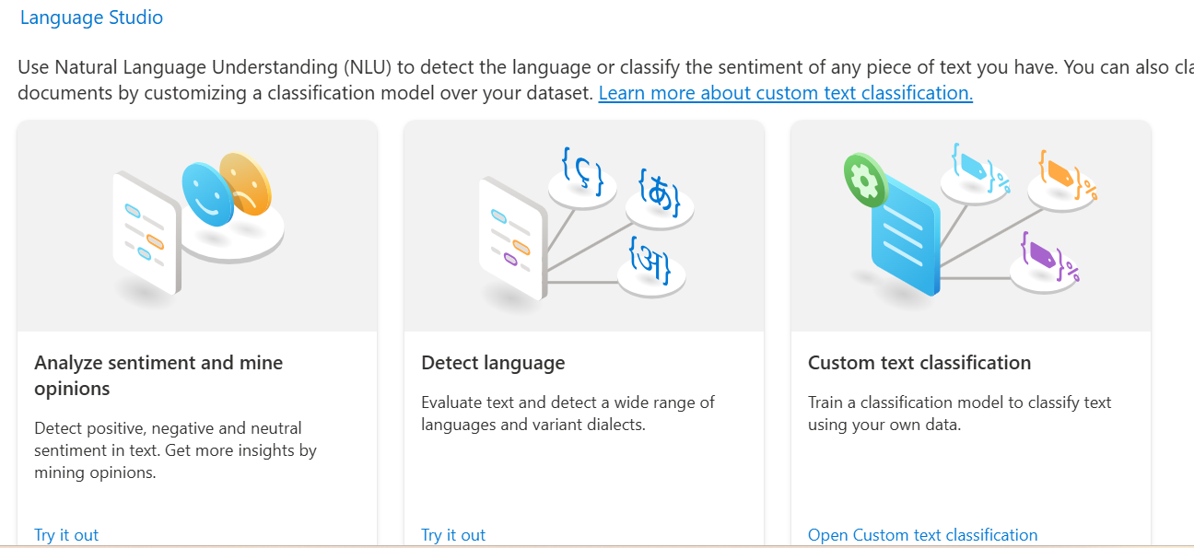

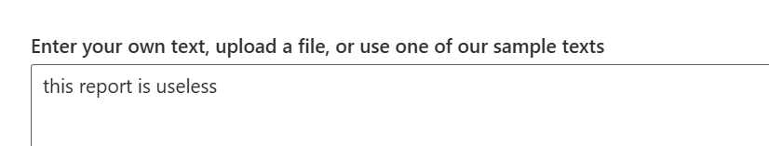
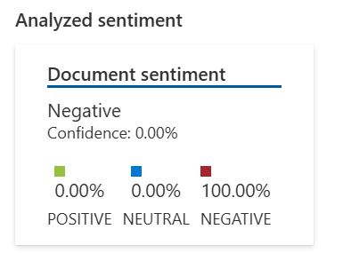
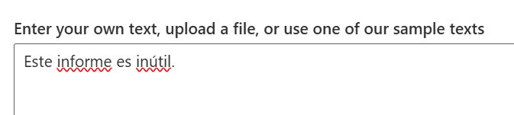
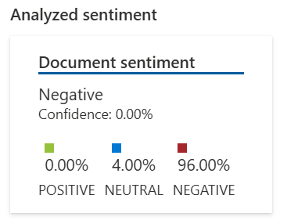
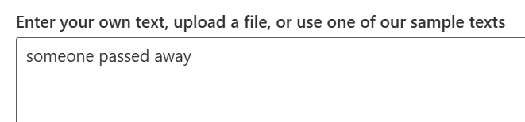
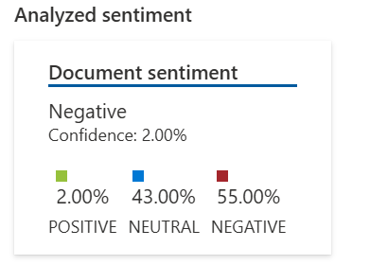
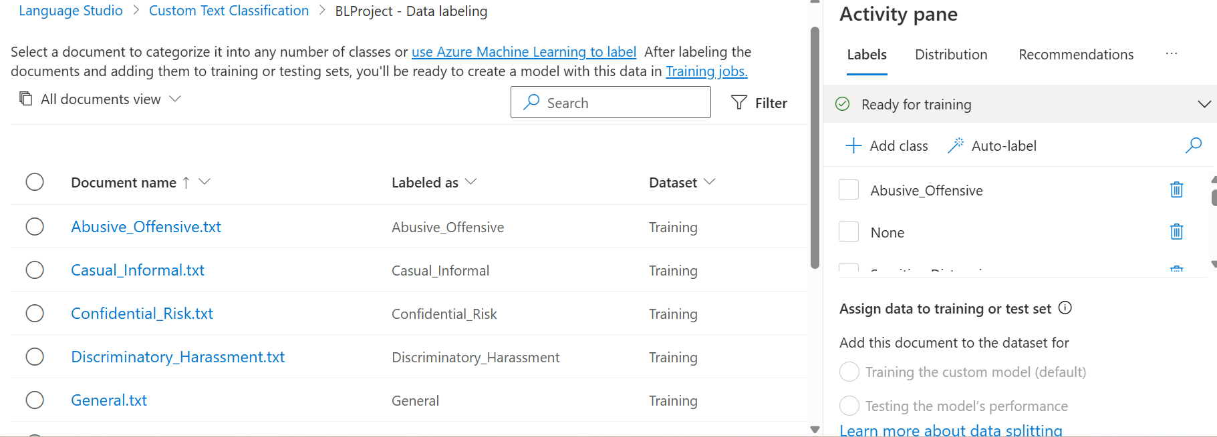

Azure Language Studio – Corporate Content Classification Schema
Category (Label) | Description | Example Texts
Professional | Clear, respectful, and work-appropriate communication. Used for formal corporate tone or factual updates. | “Please share the Q4 revenue report by EOD.”
Abusive_Offensive | Contains insults, profanity, or unprofessional language. | “This is so stupid.” / “You’re useless.”
Sensitive_Distressing | Mentions death, illness, or other emotionally distressing topics. | “Our senior manager passed away.”
Confidential_Risk | Mentions private company data, client details, or PII. | “Here’s the customer’s credit card info.”
Discriminatory_Harassment | Contains biased, threatening, or harassing content. | “Women can’t handle leadership roles.”
Spam_Irrelevant | Promotional, unrelated, or non-business content. | “Join this crypto investment group!”
Typo_GrammarIssue | Contains spelling mistakes, grammatical errors, or poor language structure. | “This is so stuppid.”
Clear_Informative | Well-written and easy to understand; provides useful information. | “The deployment is scheduled for 10 AM tomorrow.”

Optional:
- Casual_Informal
- Compliance_Violation
- Vague_Unclear

